7.3.13 Editors - 3D View - Sidebar - Tool Tab - Grease Pencil - Vertex Paint Mode
Grease Pencil - Vertex Paint Mode 2
Brushes Panel 2
Brush Browser 2
Brush Specials 2
Reset 2
Reset all Brushes 2
Custom Icon 2
Brush Name Edit Box 2
Brush Settings Panel 3
Radius 3
Use Pressure 3
Strength 3
Use Pressure 3
Brush Settings Panel - Cursor Sub panel 3
Show Brush 3
Color 3
Color Panel 3
Material / Vertex Color 3
Color picker 3
Active color 4
Brush colors flip 4
Mode 4
Mix Factor 4
Color Panel - Palette sub panel 4
Palette browser 4
Edit Box 4
Number of users 4
Fake User 5
Add palette 5
Remove Palette 5
New Palette color 5
Delete Palette color 5
Move Palette Color up and down 5
Sort By 5
Palette Colors 5
Falloff Panel 5

Grease Pencil - Vertex Paint Mode

In draw mode you can paint whole strokes with vertex color. In Vertex Paint mode you can paint the single vertices of a stroke with vertex color.

Brushes Panel
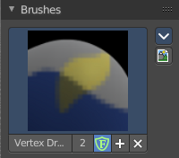

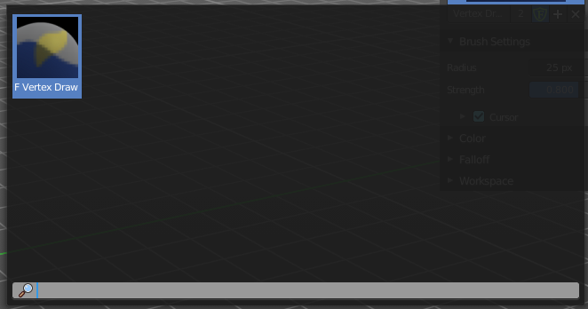
Brush Browser
Choose between the different draw, fill and erase brushes. It's the same than in the tool shelf.

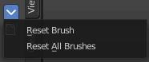
Brush Specials

Reset
Reverts the brush to the factory settings.

Reset all Brushes
Reverts all brushes to the factory settings.

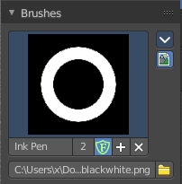
Custom Icon
The button at the right allows you to load a custom icon for your brush. It reveals a file browser below the image browser.

Brush Name Edit Box
The edit box below the Image shows you the name of the current active brush.
The number right of it, in this case 2, indicates how much number of users ( internally ) this brush uses. This means that this data block (the brush) shares currently settings with at least one other object. Most probably the parent brush where we have created it from. Click at the value to make this brush a single user. The button will vanish then.
Fake User set the brush to have a fake user. Zero user data-blocks are normally not saved. But sometimes you want to force the data to be kept even when the data block has no user.
The + button allows you to add a new pencil with the current settings. Note that the brushes are NOT saved when you close Bforartists. You can save them into the current blend file. Or you can save the startup file. But be careful here. This saves everything else of the current state of Bforartists too.
The X button deletes the brush as the active one. It does NOT delete it from the

Brush Settings Panel

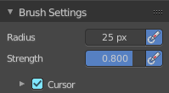
Radius
The radius of the brush.

Use Pressure
Use tablet pressure.

Strength
The strength of the brush.

Use Pressure
Use tablet pressure.

Brush Settings Panel - Cursor Sub panel
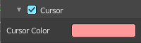

Show Brush
Show the brush icon when painting.

Color
The brush icon color.

Color Panel
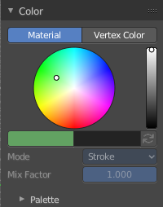
The default grease pencil color is based at materials. And then this panel is greyed out and dysfunctional. But you can also choose to work with vertex colors instead. And then all the color panel features becomes activated.

Material / Vertex Color
Choose if you want to work with material based colors or with vertex colors. Turn it to vertex colors to activate the features.
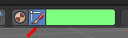
This can also be done in the tool settings in the header.

Color picker
Define the color for your brush.

Active color
The active color is the left one. When you click the button with the two arrows down right then you can swap the color with the secondary color. Then this secondary color becomes the primary color, and is active.
A click at one of the color fields will open a more detailed color dialog, where you can set up the color by using rgb, hsv and hex colors and with value sliders.

Brush colors flip
Flips the primary color with the secondary color.

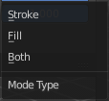
Mode
How the vertex color is applied.

Mix Factor
Factor used to mix the vertex color to get final color.

Color Panel - Palette sub panel

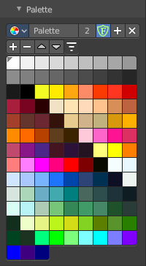
Here you will find a predefined color palette, and here you can create a color palette for later reuse.
The color palette cannot be saved externally. It is part of the current blend file. You can however append color palettes from other blend files.
The currently active color is the one with the triangle at it.

The elements are explained from left to right and from top to bottom.

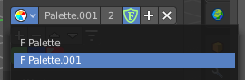
Palette browser
The button at the left opens a drop down list to choose between your palettes.

Edit Box
Read the name of the currently active palette. You can also rename the palette here. A click into the edit box makes the name editable.

Number of users
The number of users the palette currently has.

Fake User
Fake User sets the element to have a fake user. Zero user data-blocks are normally not saved. But sometimes you want to force the data to be kept even when the data block has no user.

Add palette
Add a new palette.

Remove Palette
Clicking at this button removes the palette. Note that you need to save, close Bforartists and reload the blend file to remove the palette completely.

New Palette color
Adjust a color in the color picker. Then click at the add button to add this color to the palette.

Delete Palette color
Select the color in the palette, then click at the minus button to remove it.

Move Palette Color up and down
With these two buttons you can move the active color up or down in the palette.

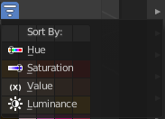
Sort By
Sort the palette by different methods.

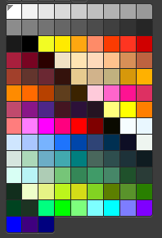
Palette Colors
The actual list of the current palette colors. Click at one to make it the active one that gets used for painting.

Falloff Panel

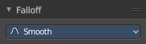
Adjust the brush falloff.

